Boston 1770: Riot or Massacre?

Directions: On the night of March 5, 1770, several Boston residents were shot and killed by British soldiers in what became known as the Boston Massacre. What follows are several images and first-hand accounts from eyewitness to and participants in the event.
Primary source #1: Report of the Committee of the Town of Boston
- What is the perspective of the Committee of the Town of Boston? How do you know?

- What words used by the Committee make a strong argument against the British?

Would the Boson committee label the events as a riot or massacre? Circle your choice below:
Riot | Massacre
Explain your reasoning in a complete sentence: _________________________________ ________________________________________________________________________________________________________________________________________________________________________________________________________________________
Primary source #2: Testimony from Bostonian William Tant
- What is the perspective of William Tant? How do you know?

- According to the source, what did the crowd do that may have frightened the soldiers into thinking they might be attacked by the people in the street?

Would William Tant label the events as a riot or massacre? Circle your choice below:
Riot | Massacre
Explain your reasoning in a complete sentence: _________________________________ ________________________________________________________________________________________________________________________________________________________________________________________________________________________

Primary source #3: Testimony from [British] Captain Thomas Preston

- What is the perspective of Captain Thomas Preston? How do you know?

Would Captain Preston label the events as a riot or massacre? Circle your choice below:
Riot | Massacre
Explain your reasoning in a complete sentence: _________________________________ ________________________________________________________________________________________________________________________________________________________________________________________________________________________

Primary Source #4: An excerpt from Diary and Autobiography of John Adams

- What is the perspective of John Adams? How do you know?

- Is John Adams proud of his role as defense attorney for Captain Preston and the other British soldiers? What words or sentences from this quotation support that?

Would John Adams label the events as a riot or massacre? Circle your choice below:
Riot | Massacre
Explain your reasoning in a complete sentence: _________________________________ ________________________________________________________________________________________________________________________________________________________________________________________________________________________
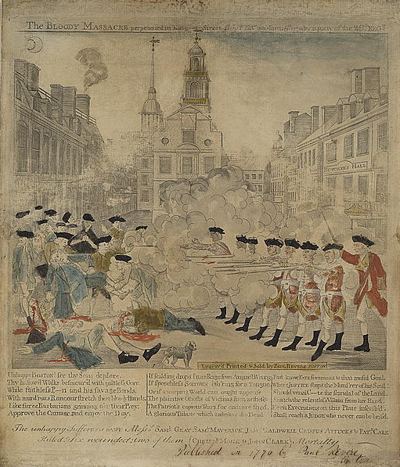
Primary Source #5: Paul Revere’s engraving, “The Bloody Massacre Perpetrated in King-Street…”

- What is the perspective of Paul Revere? How do you know?

- Compare the behavior and actions of the British soldiers and the colonists according to the engraving. What is each group doing according to Paul Revere?
Colonists | British Soldiers

Would Paul Revere label the events as a riot or massacre? Circle your choice below:
Riot | Massacre
Explain your reasoning in a complete sentence: _________________________________ ________________________________________________________________________________________________________________________________________________________________________________________________________________________

