Boston 1770: Riot or Massacre?
Primary source #1: Report of the Committee of the Town of Boston
2d – second
Contentious – likely to cause an argument
Disposition – a person’s qualities that make up his or her character
Promiscuously – casual; irregular; without caution
Inquiry – a question

Primary source #2: Testimony from Bostonian William Tant
Customs-house – a government building that collects taxes on imported goods
Sentry-box – a structure providing shelter for a standing soldier or sentry

Primary source #3: Testimony from [British] Captain Thomas Preston
Bayonet – swordlike stabbing blade at the end of a gun
Endeavoring – an attempt to achieve a goal
Imminent – immediate, unavoidable

Primary Source #4: An excerpt from Diary and Autobiography of John Adams
Procured – obtain something with a lot of effort
Obloquy – strong public criticism or verbal abuse
Gallant – brave, heroic
Quakers – religious group of the colonial period, Christian
Verdict – a decision on a disputed issue
Standing Armies - permanent, professional army of full time soldiers

Primary Source #5: Paul Revere’s engraving, “The Bloody Massacre Perpetrated in King-Street…”
Besmeared – smear or cover with a substance
Rancour – bitterness or resentfulness
Appease – relieve or satisfy
Plaintive – sounding sad or mournful
Copious – large amount

Primary source #1: Report of the Committee of the Town of Boston
On Friday, the 2d instant, a quarrel arose between some soldiers of the 29th, and the ropemakers journeymen and apprentices, which was carried to that length, as to become dangerous to the lives of each party, many of them being much wounded. This contentious disposition continued until the Monday evening following, [March 5th] when a party of seven or eight soldiers were detached from the main guard, under the command of Captain Preston, and by his orders fired upon the inhabitants promiscuously in King Street, without the least warning of their intention, and killed three on the spot; another has since died of his wounds, and others are dangerously, some it is feared mortally, wounded. Captain Preston and his party are now in jail. An inquiry is now making into this unhappy affair…

Primary source #2: Testimony from Bostonian William Tant
…I saw a party of soldiers come from the main guard, and draw themselves up in a line from the corner of the Customs-house to the sentry-box; the people still continued in the street, crying “Fire, fire, and be damned,” and hove [throw] some more snow balls; whereupon I heard a musket go off, and in the space of two or three seconds, I heard the word “Fire” given, between the sentry-box and the Custom-house door. And further I know not.

Primary source #3: Testimony from [British] Captain Thomas Preston
They [the mob] advanced to the points of the bayonets, struck some of them and even the muzzles [the front of the muskets] of the pieces, and seemed to be endeavoring to close with the soldiers… some well behaved persons asked me if the guns were charged [loaded] and I replied yes… they then asked if I intended to order the men to fire. I answered no, by no means, observing to them that I was advanced before the muzzles of the men’s pieces [he was standing in front of their guns] and much fall a sacrifice if they fired; and my giving the word fire under those circumstances would prove me to be no officer. While I was thus speaking, one of the soldiers have received a severe blow with a stick, stepped a little on one side and instantly fired, on which turning and asking why he fired without orders, I was struck with a club on my arm, which for some time deprived me of the use of it, which blow had it been placed on my head, most probably would have destroyed me.

Primary Source #4: An excerpt from Diary and Autobiography of John Adams
I have Reason to remember that fatal Night. The Part I took in Defense of Captn. Preston and the Soldiers, procured me Anxiety, and Obloquy enough. It was, however, one of the most gallant, generous, manly and disinterested Actions of my whole Life, and one of the best Pieces of service I ever rendered my Country. Judgment of Death against those Soldiers would have been as foul a Stain upon this Country as the Executions of the Quakers or Witches, anciently. As the Evidence was, the Verdict of the jury was exactly right.
This however, is no Reason why the Town should not call the Action of that Night a Massacre, nor is it any Argument in favour of the Governor or Minister, who caused them to be sent here. But it is the strongest Proofs of the Danger of Standing Armies.
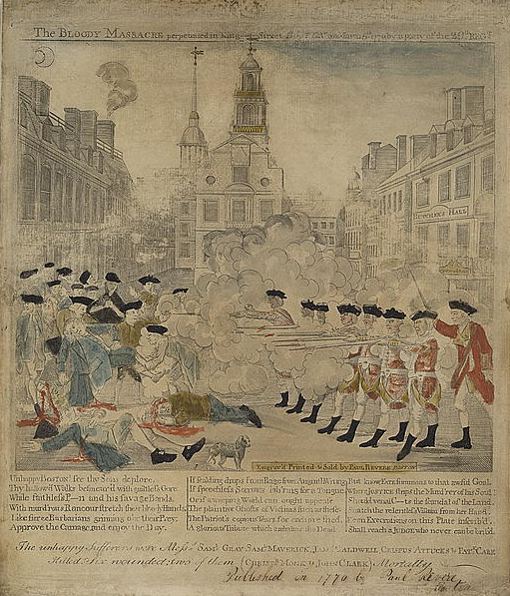
Primary Source #5: Paul Revere’s engraving, “The Bloody Massacre Perpetrated in King-Street…”

Paul Revere, “The Bloody Massacre”
Unhappy Boston ! See thy Sons deplore.
Thy hallow'd Walks besmear'd with guiltless Gore.
While faithless P n [Preston] and his savage Bands,
With murd'rous Rancour stretch their bloody Hands;
Like fierce Barbarians grinning o'er their Prey,
Approve the Carnage, and enjoy the Day.

If scalding drops from Rage from Anguish Wrung
If speechless Sorrows lab'ring for a Tongue,
Or if a weeping World can aught appease
The plaintive Ghosts of Victims such as these;
The Patriot's copious Tears for each are shed,
A glorious Tribute which embalms the Dead.

