Document A: Eisenhower’s D-Day Letter to U.S. Troops
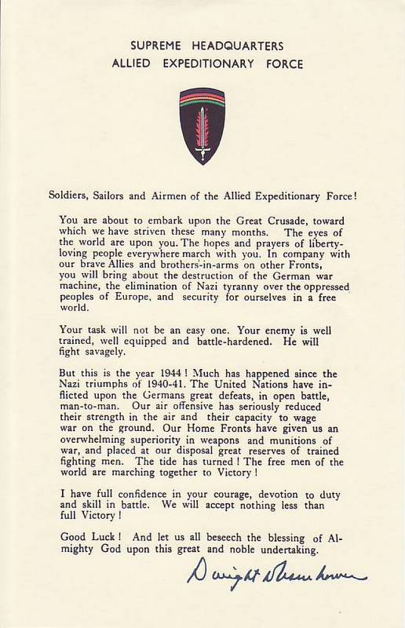

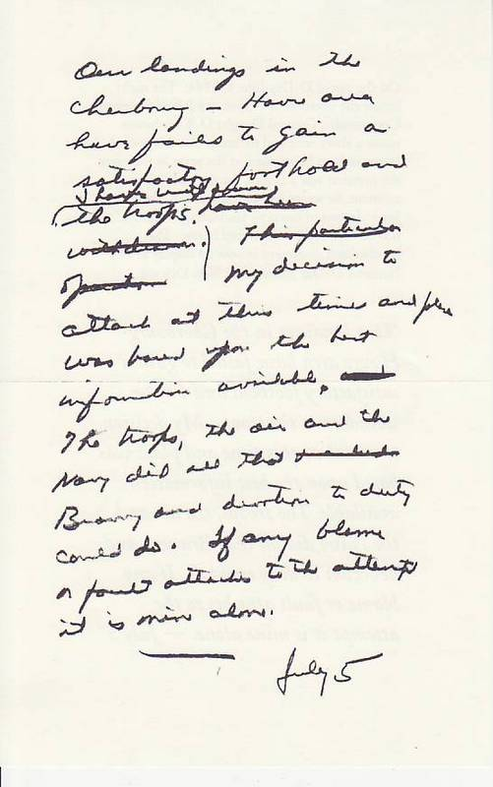
Document B: Eisenhower’s Private Letter

Transcript: "Our landings in the Cherbourg-Havre area have failed to gain a satisfactory foothold and I have withdrawn the troops. My decision to attack at this time and place was based upon the best information available. The troops, the air and the Navy did all that Bravery and devotion to duty could do. If any blame or fault attaches to the attempt it is mine alone. -- July 5"
Document C: Eisenhower’s Order to Germans

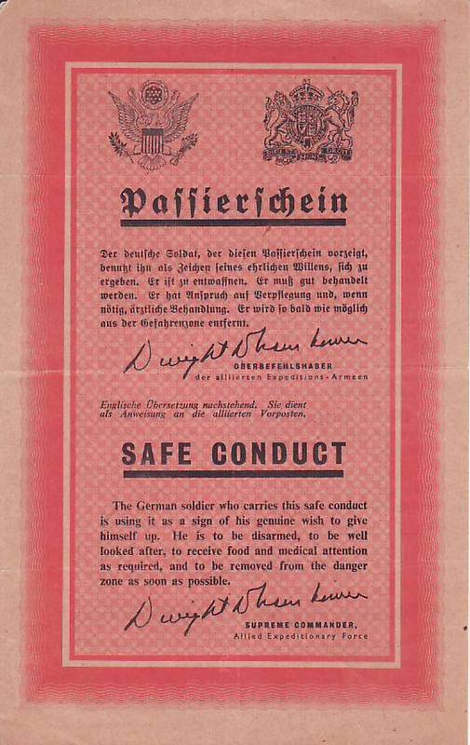
Voices of D-Day: Bob Slaughter
I was really keyed up and so were my buddies, and we went around. I know I took my General Eisenhower message that was issued to all of us, and I got autographs of all my buddies and everybody I could get to autograph it.

As our teams were called, we assembled on the landing craft and were lowered into the water, and it was tremendously rough and the spray from the sea was cold, and it came over the sides of the landing craft and nearly everybody got soaked. We were taking water from the rough sea over the bow, and we were bailing to try to keep afloat. Some of the landing craft sank before they got in because of the rough sea. In fact, we picked up some of our buddies who had floundered eight or nine miles from shore, and we had taken them on as extra cargo; and some that we should have picked up or would have liked to have picked, we left because we didn't have room. We hoped somebody else would.

It was a terrible ride to the beach. Over to our right, the battleship Texas was firing into the cliffs, and every time that big fourteen inch gun went off, a tremendous tsunami swamped our boat, and the water would come over the side and just soak us and make our seasickness worse.

As we got in to one thousand yards offshore, we started taking some mortar shells and some artillery. They were just over our bow and exploding off to our side, and we could also hear the small arms as we got in a little closer -- the small arms were firing at us.

Voices of D-Day: Thomas Valence
We proceeded toward the beach, and many of the fellows got sick. The water was quite rough. It was a choppy ride in, and we received a lot of spray.
Our boat was one of six of A Company in the first wave, and when we got to the beach, or close to it, the obstacles erected by the Germans to prevent the landing were fully in view, as we were told they would be, which meant the tide was low.
I was the rifle sergeant and followed Lieutenant Anderson off the boat, and we did what we could rather than what we had practiced doing for so many months in England. There was a rather wide expanse of beach, and the Germans were not to be seen at all, but they were firing at us, rapidly, with a great deal of small-arm fire.
As we came down the ramp, we were in water about knee high, and we started to do what we were trained to do -- move forward, and then crouch and fire. One of the problems was we didn't quite know what to fire at. I saw some tracers coming from a concrete emplacement, which to me looked mammoth. I never anticipated any gun emplacements being that big. I attempted to fire back at that, but I had no concept of what was going on behind me. There was not much to see in front of me except a few houses, and the water kept coming in so rapidly, and the fellows I was with were being hit and put out of action so quickly that it become a struggle to stay on one's feet. I abandoned my equipment, which was very heavy.
I floundered in the water and had my hand up in the air, trying to get my balance, when I was first shot. I was shot through the left hand, which broke a knuckle, and then through the palm of the hand. I felt nothing but a little sting at the time, but I was aware that I was shot. Next to me in the water, Private Henry G. Witt was rolling over towards me. "Sergeant, they're leaving us here to die like rats. Just to die like rats." I certainly wasn't thinking the same thing, nor did I share that opinion. I didn't know whether we were being left or not.
I made my way forward as best I could. My rifle jammed, so I picked up a carbine and got off a couple of rounds. We were shooting at something that seemed inconsequential. There was no way I was going to knock out a German concrete emplacement with a .30-caliber rifle. I was hit again, once in the left thigh, which broke my hipbone, and a couple of times in my pack, and then my chinstrap on my helmet was severed by a bullet. I worked my way up onto the beach, and staggered up against a wall, and collapsed there. The bodies of the other guys washed ashore, and I was one live body amongst many of my friends who were dead and, in many cases, blown to pieces.
Eisenhower & D-Day DBQ

Directions: Read the three documents written by Eisenhower in relation to the invasion of France known commonly as D-Day. Then answer the questions related to documents A-C and answer the concluding question.

Document A: Eisenhower’s D-Day Letter to U.S. Troops

- What is the author’s purpose in writing this letter? How do you know his purpose? Provide evidence (quote the text).

- According to this letter, what does Eisenhower see as the outcome of Operation Overlord (D-Day)? Provide evidence for your answer.

Document B: Eisenhower’s Private Letter

- What is the author’s purpose in writing this letter? How do you know his purpose? Provide evidence (quote the text).

- According to this letter, what does Eisenhower see as the outcome of Operation Overlord (D-Day)? Provide evidence for your answer.

Document C: Eisenhower’s Order to Germans

- What is the author’s purpose in writing this order? How do you know his purpose? Provide evidence (quote the text).

- According to this letter, what does Eisenhower see as the outcome of Operation Overlord (D-Day)? Provide evidence for your answer.

Conclusion: Was Eisenhower confident in his troop’s ability to win D-Day or was he expecting failure? Use at least 2 of the documents in your response.

_________________________________________________________________________________________________________________________________________________________________________________________________________________________________________________________
_________________________________________________________________________________________________________________________________________________________________________________________________________________________________________________________
____________________________________________________________________________________________________________________________________________________________________________________________________________________________________________________________________________________________________________________________________________

