My Illinois Choice Assessment
Directions: In order to complete this project, you have a couple of options. You must choose one project from Section III and a combination of choices from Sections I and II. Your point total from your project choices should add up to 50 points. This Assessment is in place of a regular test; see the rubric on the back.
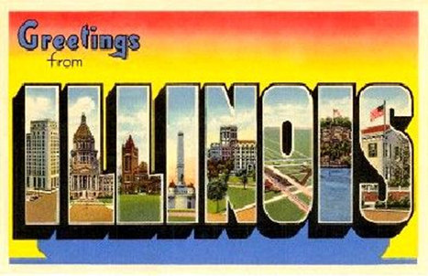
Section I: Each choice is worth 10 points
- Create a venn diagram that compares and contrasts federal and state government. You should be able to demonstrate how the U.S. and Illinois Constitutions are similar and different.
- Create a citizen profile. Include information about your current representatives and your legislative districts.
Section II: Each choice is worth 15 points
- Write an opinion article that provides three pieces of evidence as to why Illinois is or is not a good state to live.
- Complete a report on the 2014 Gubernatorial Election. Include information about the race (what did each candidate stand for), the actual election, and the results.
Section III: Choose one for 25 points
- Create a poster to represent the images that come to your mind when you think about the state in which you live. The representation MUST include the state bird, the state animal, the state slogan, the state flower, the state tree, and at least 2 other items, locations, or ideas that represent what Illinois means to you. It must be neat and colorful.
- Create a poem or song to represent what comes to your mind when you think about the state in which you live. The representation MUST include the state bird, the state animal, the state slogan, the state flower, the state tree, and at least 2 other items, locations, or ideas that represent what Illinois means to you. The lyrics must be typed and it should have at least 4 stanzas of 4 lines.
- Create a short story/creative writing piece to represent what comes to your mind when you think about the state in which you live. The representation MUST include the state bird, the state animal, the state slogan, the state flower, the state tree, and at least 2 other items, locations, or ideas that represent what Illinois means to you. Your short story or creative writing piece can be humorous, serious, or informative. However, it must be school appropriate.
Helpful Websites and Resources for Research
- https://www.illinois.gov/
  - Under the “government” tab, there is a lot of relevant information
- http://www.270towin.com/2014-governor-election/illinois
  - Ratings of the two candidates for governor
- http://gis.elections.il.gov/map_viewer_update/default.aspx
  - GIS map of legislative districts
  - Enter in your address and you can see your representatives (Citizen Profile)
- https://www.govtrack.us/congress/members/IL
  - Profiles on the members of the Illinois General Assembly
- http://votesmart.org/
  - Interesting and descriptive information on individual politicians
  - Not a ton of local politicians are featured, but there are some
- Illinois Constitution Handbook
My Illinois Choice Assessment Rubric
 | Exceeds | Meets | Does Not Meet
Project Completion  (50 points) | - 3 components are completed  - Instructions are followed  - Student displays creativity and extra effort | - 3 components are completed  - Instructions are followed | - At least one criteria is not met  - Does not follow instructions  - Late or incomplete
Display of Concepts  (10 points) | - Student has a clear understanding of the concepts for the Illinois Constitution  - Student clearly demonstrates concepts | - Student has a basic understanding of the concepts for the Illinois Constitution  - Student sometimes clearly demonstrates concepts | - From the work provided, it is not always evident that the student displays a clear understanding of the concepts
Organization  (5 points) | - Grammar, flow, and mechanics are correct | - Proper mechanics are attempted and evident | - Student’s work is difficult to read

Choice 1: ____________________________________________
Choice 2: ____________________________________________
Choice 3: Section 3 project

