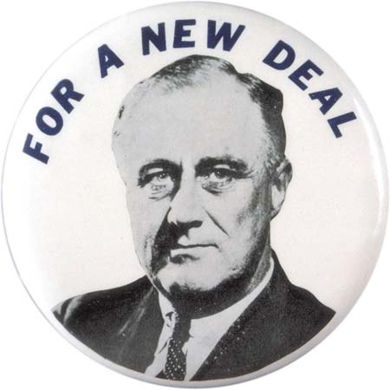
New Deal Programs: Relief, Recovery, Reform

Part 1: New Deal Investigation

Directions: Identify 3 important New Deal Programs that fit the function outlined by Franklin Roosevelt (relief, reform, or recovery). Write the full name of the agency and the abbreviation. Finally, explain what information about the agency helps you to know that this was the focus of that program.

New Deal Agency | Relief, Recovery, or Reform? | How do you know?
 | Relief
 | Reform
 | Recovery
Part 2: New Deal Synthesis (10 points)

Directions: This semester, we have talked a lot about the different social, economic and political problems that started to face America during the Gilded Age. Using your notes, your textbook and Internet research, form an answer to the following questions. When you answer the questions, your argument MUST be supported by evidence.

- Which of the three focus points of the New Deal were the most important (Relief, Reform, or Recovery)? When you answer this question, be sure to reference at least 2 New Deal agencies.

______________________________________________________________________________________________________________________________________________________________________________________________________________________________________________________________________________________________________________________________________________________________________________________________________________________________________________________________________________________________________________________________________________________________________________________________________________________________________________________________________________________________________________________________________________________________________________________________________________________________________________________________________________________________________
______________________________________________________________________________________________________________________________________________________________________________________________________________________________________________________________________________________________________________________________________________________________________________________________________________________________________________________________________________________________________________________________________________________________________________________________________________________________________________________________________________________________________________________________________________________________________________________________________________________________________________________________________________________________________

