Presidential Aging
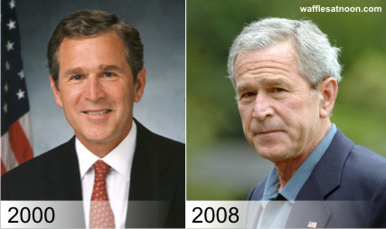

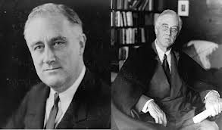
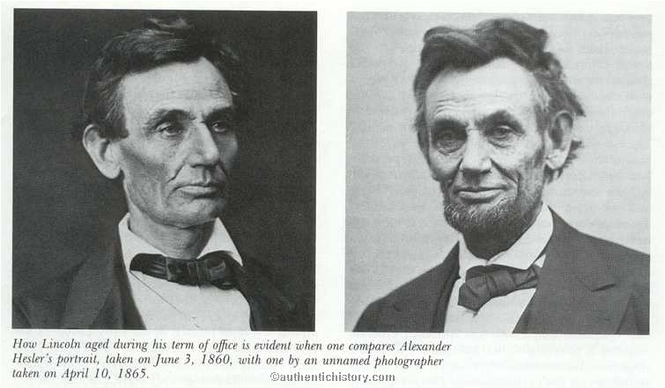

Primary Source Analysis
Directions: Use the Political Cartoon below to answer the following questions. Use complete sentences.
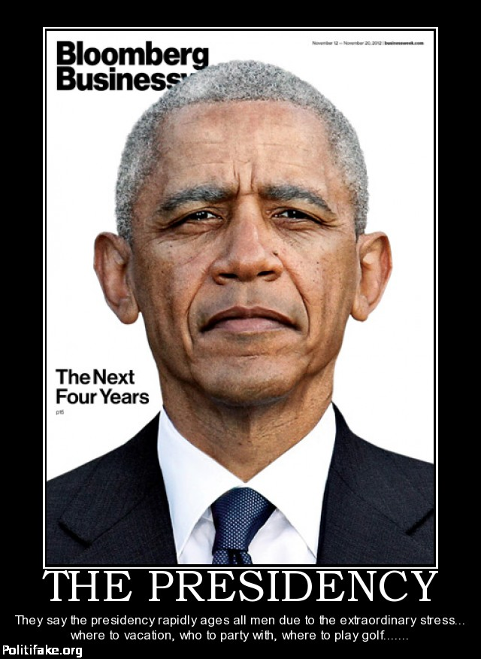
- Who is depicted in this Political Cartoon?

- When do you think this Cartoon was made? Why do you think this?

- What does the Cartoon say about the job of the President? What evidence from the source convinces you of this?

- What does the author of this primary source think about President Obama? What evidence shows the author’s bias?

- Do you agree with this Political Cartoon? (Use your knowledge of the Constitution, the Executive Branch, and the Cartoon to form your response.)

