WWII: Minister of Propaganda
Part 1: Identify Types of Propaganda
Directions: View the WWII propaganda posters around the room and fill out the graphic organizer. Then answer the question at the bottom.
Poster # | Type of Propaganda | Intended Audience(i.e. US farmers, US young men) | What is the poster trying to get its audience to do?
1
2
3
4
5
6

Conclusion: In your opinion, which of the posters was most successful? Why?

Part 2: Perspectives of Propaganda
Directions: For the two images assigned you must create two different captions/slogans for each image. One slogan will be from the Axis perspective and one from the Allied perspective.
Image 1: Hitler in front of the Eiffel Tower
Allied Perspective Caption/Slogan: | Axis Perspective Caption/Slogan:
Propaganda Technique Used:  Explanation: | Propaganda Technique Used:  Explanation:

Image 2: Japanese Airplane
Allied Perspective Caption/Slogan: | Axis Perspective Caption/Slogan:
Propaganda Technique Used:  Explanation: | Propaganda Technique Used:  Explanation:

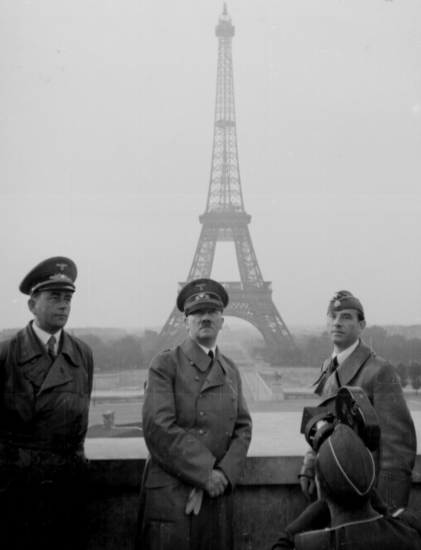
Part 2: Image 1 (Hitler in front of Eiffel Tower)

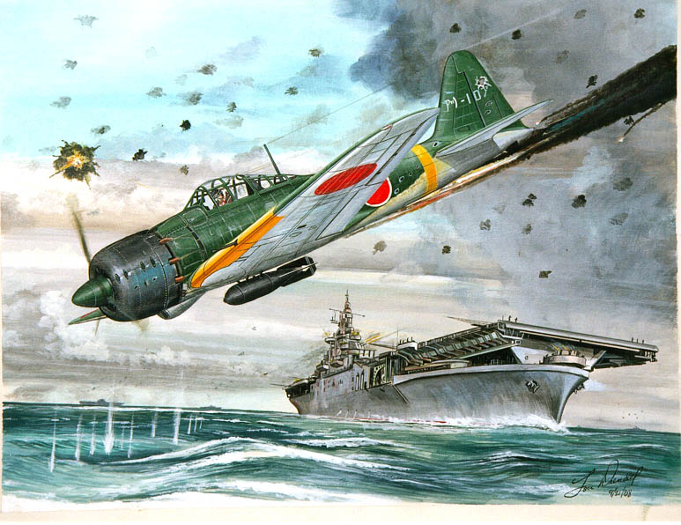
Part 2: Image 2 (Japanese Airplane)

Part 1: Poster 1
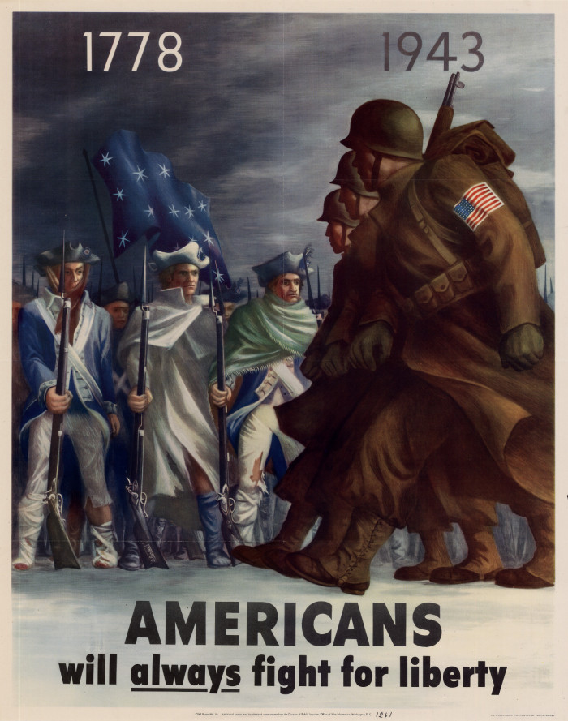

Part 1: Poster 2
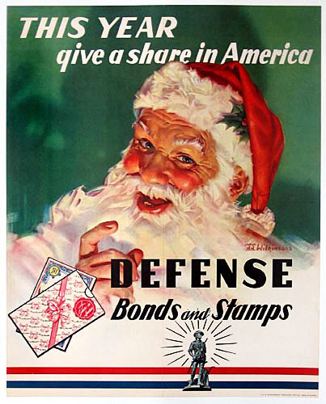

Part 1: Poster 3
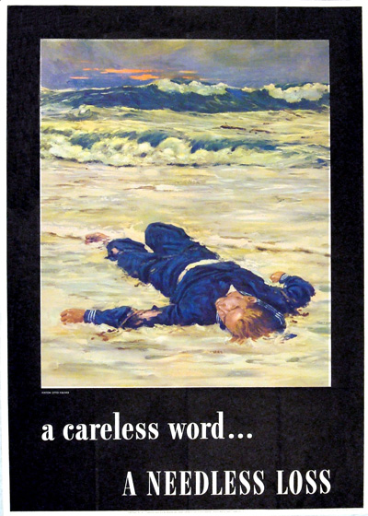

Part 1: Poster 4

Part 1: Poster 5
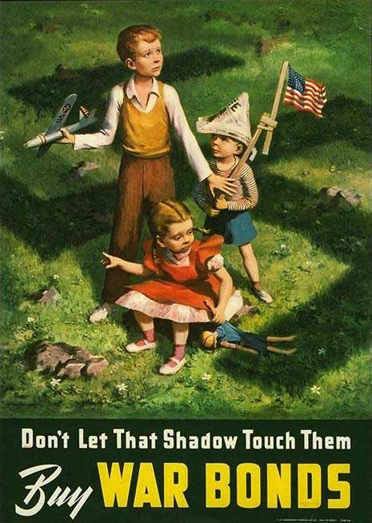

Part 1: Poster 6
