Should Mrs. VanGorder (and history teachers in general) use the movie “Lincoln” in class?
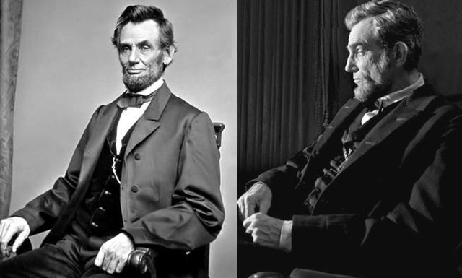

Task: You need to come up with an argument to convince me whether or not I should show the movie, “Lincoln” as a teaching tool.

Directions: When making an argument, a writer must provide at least 2 reasons with evidence as to why his or her position is the best option. You can structure your argument in whatever way you choose but you must use TWO different sources to provide support for your argument.

Schedule Outline:
- Day 1: Debate Intro and clip from “Lincoln”
  - The Unofficial Teacher’s Guide to Spielberg’s “Lincoln” (http://housedivided.dickinson.edu/sites/emancipation/spielberg/)
- Day 2: Research and Example
  - Clip exhibiting why I should show the film
    - Lincoln and War Power – Cabinet Meeting
- Day 3: Research and Example
  - Clip exhibiting why I should not show the film
    - Lincoln and Robert
- Day 4: Collaboration
  - Meet with your group and decide how to present your argument
- Day 5: Debate
  - ARGUE FOR YOUR LIVES

Note: Your participation in this activity in addition to your participation in the annotation will determine whether or not you pass or fail this Power Hour.

