The Blue & the Gray: An Overview of the Civil War

 | Union | Confederate
Flag | 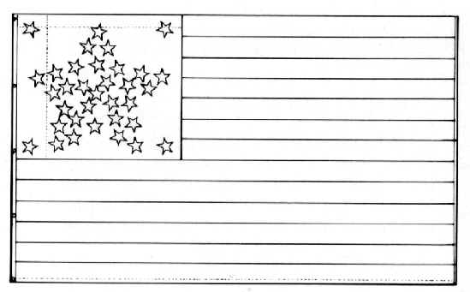 | 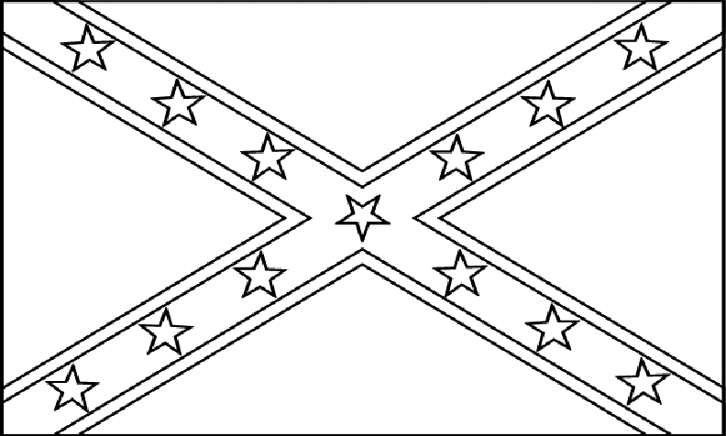
Political Leaders

#1 & #2: Military Leaders | Type of Leader:  Examples: | Type of Leader:  Examples:
 | Union | Confederate
#3: Major Victories

#3: Major Defeats

#4: Casualties

Stations:
- Everyone: A Brief Overview of the Civil War, James McPherson
  - http://www.civilwar.org/education/history/civil-war-overview/overview.html

- #1: Union Leaders
  - http://www.civilwar.org/education/in4/union-leaders.html

- #2: Confederate Leaders
  - http://www.civilwar.org/education/in4/confederate-leaders.html

- #3: Battles – Skirmishes, Victories & Defeats
  - Military Engagements: http://www.civilwar.org/education/in4/military-engagements.html
  - Infographic: http://www.civilwar.org/resources/battles-of-the-civil-war-infographic.html#.T_XEKfV0n-I

- #4: Casualties – The Cost of War
  - http://www.civilwar.org/education/civil-war-casualties.html

