Who is Mrs. VanGorder?!
(15 points)
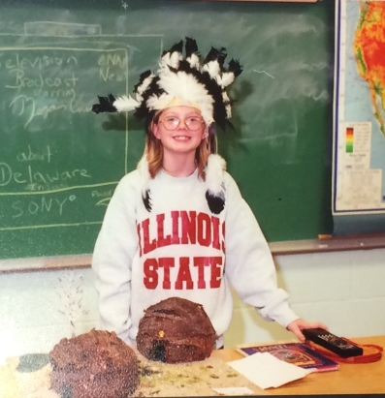
Directions: On this first day of your eighth grade year, I could go easy on you. I could tell you all about me and what this year might hold based on who I am and what I know about history. But that would be too easy! Instead, I want you to investigate (like historians) and tell me about who I am.
Go to each of the stations, and write down your observations about my life in bullet points. Carefully consider the text on each artifact and what it might mean.
Note: Please handle the artifacts carefully. Some of them are old(er) and should be treated as very important documents… because they are! If you ruin them, my mom might be mad.
PART I: Station Observations
Station 1  Artifacts:  Significance: | Station 2  Artifacts:  Significance:
Station 3  Artifacts:  Significance: | Station 4  Artifacts:  Significance:
Station 5  Artifacts:  Significance: | Station 6  Artifacts:  Significance:

PART II: Conclusions
Directions: After you have been to each of the stations, compile your observations in complete sentences. Based on what you have found, who is Mrs. VanGorder? Use the evidence to support your conclusions.
________________________________________________________________________________________________________________________________________________________________________________________________________________________________________________________________________________________________________________________________________________________________________________________________________________________________________________________________________________________________________________________________________________________________________________________________________________________________________________________________________________________________________________________________________________________________________________________________________________________________________________________________________________________________________________________________________________________________________

